**HOTEL MANAGEMENT SYSTEM**



**by:Aanchal,Shreya,Tarunikka**

**12 A**

# CONTENTS

| **S.NO.** | **TOPIC** |
| --- | --- |
| **1.** | **INTRODUCTION** |
| **2.** | **OBJECTIVE OF THE PROJECT** |
| **3.** | **SOURCE CODE AND OUTPUT** |
| **4** | **BIBLIOGRAPHY** |

**INTRODUCTION**

**To increase the global reach of a hotel website. Through it, hoteliers are able to launch hotel website so that various users around the world can access the website. Thus it increases the chances of a number of bookings. Also, it saves a lot of time and effort for customers as they can conveniently book hotel rooms from their homes.**

**Other objectives fulfilled by online hotel management systems are:**

**• To provide a platform to manage on-desk and online bookings**

**• To display organized information of hotel, prices and pictures.**

**• View of availability of rooms in real time.**

**• Store customer information which can be accessed anytime.**

**• A user-friendly interface for customers for the easy booking process.**

**• To provide a secure payment gateway for online transaction.**

**So keeping these things in views, I have computerized my small project work “Hotel Management System”. Have maintained this project work on the suitable and advance language i.e. “Python” and “MySQL”.**

**OBJECTIVE**

**The objective of Hotel Management system is to develop a project which maintains booking of rooms and handles accounts of a hotel. In this software, the hotel manager can add new customers and manage that customer information. Restaurant manager can add restaurant bill in that customer bill. This software works at all hotels that cater to a large number of customers and want to computerize the complete management process.**

**This software is aimed at facilitating the prompt, accurate and easy management of a hotel. It will be very helpful to the manager on the one hand and to the customers as they would be able to get good and fast service.**

**TABLES:**

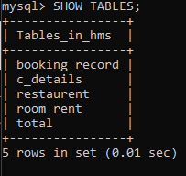

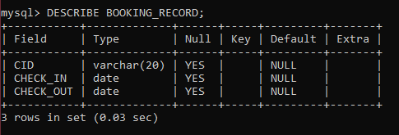

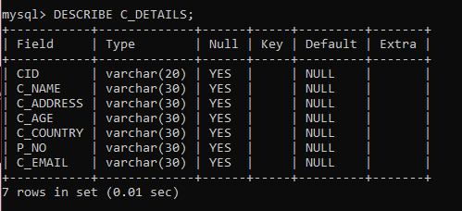

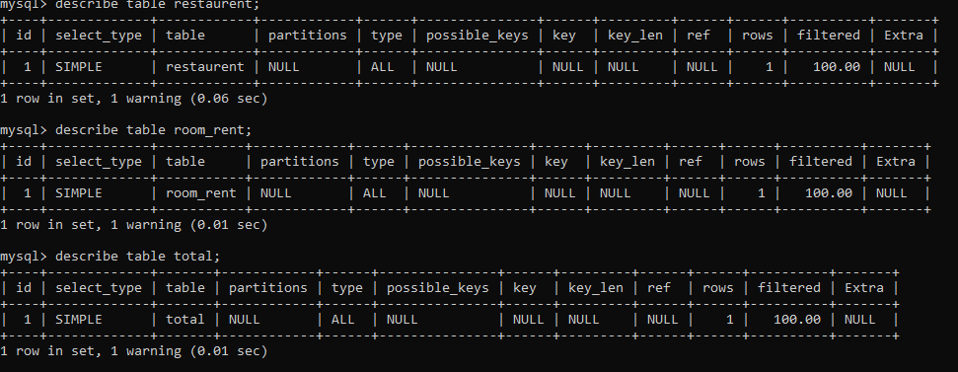

**SOURCE CODE:**

**import mysql.connector**

**# GLOBAL VARIABLES DECLARATION**

**myConnnection =""**

**cursor=""**

**userName=""**

**password =""**

**roomrent =0**

**restaurentbill=0**

**totalAmount=0**

**cid=""**

**#MODULE TO CHECK MYSQL CONNECTIVITY**

**def MYSQLconnectionCheck ():**

**global myConnection**

**global userName**

**global password**

**userName = input("\n ENTER MYSQL SERVER'S USERNAME : ")**

**password = input("\n ENTER MYSQL SERVER'S PASSWORD : ")**

**myConnection=mysql.connector.connect(host="localhost",user=userName,passwd=password ,auth_plugin='mysql_native_password' )**

**if myConnection:**

**print("\n CONGRATULATIONS ! YOUR MYSQL CONNECTION HAS BEEN ESTABLISHED !")**

**cursor=myConnection.cursor()**

**cursor.execute("CREATE DATABASE IF NOT EXISTS HMS")**

**cursor.execute("COMMIT")**

**cursor.close()**

**else:**

**print("\nERROR ESTABLISHING MYSQL CONNECTION CHECK USERNAME AND PASSWORD !")**

**#MODULE TO ESTABLISHED MYSQL CONNECTION**

**def MYSQLconnection ():**

**global userName**

**global password**

**global myConnection**

**global cid**

**myConnection=mysql.connector.connect(host="localhost",user=userName,passwd=password ,database="HMS" , auth_plugin='mysql_native_password' )**

**if myConnection:**

**return myConnection**

**else:**

**print("\nERROR ESTABLISHING MYSQL CONNECTION !")**

**myConnection.close()**

**def userEntry():**

**global cid**

**if myConnection:**

**cursor=myConnection.cursor()**

**createTable =('''CREATE TABLE IF NOT EXISTS C_DETAILS(CID VARCHAR(20),C_NAME VARCHAR(30),C_ADDRESS VARCHAR(30),C_AGE VARCHAR(30), C_COUNTRY VARCHAR(30) ,P_NO VARCHAR(30),C_EMAIL VARCHAR(30))''')**

**cursor.execute(createTable)**

**cid= input("Enter Customer Identification Number : ")**

**name = input("Enter Customer Name : ")**

**address = input("Enter Customer Address : ")**

**age= input("Enter Customer Age : ")**

**nationality = input("Enter Customer Country : ")**

**phoneno= input("Enter Customer Contact Number : ")**

**email = input("Enter Customer Email : ")**

**sql = "INSERT INTO C_Details VALUES(%s,%s,%s,%s,%s,%s,%s)"**

**values= (cid,name,address,age,nationality,phoneno,email)**

**cursor.execute(sql,values)**

**cursor.execute("COMMIT")**

**print("\nNew Customer Entered In The System Successfully !")**

**cursor.close()**

**else:**

**print("\nERROR ESTABLISHING MYSQL CONNECTION !")**

**def bookingRecord():**

**global cid**

**customer=searchCustomer()**

**if customer:**

**if myConnection:**

**cursor=myConnection.cursor()**

**createTable ="CREATE TABLE IF NOT EXISTS BOOKING_RECORD(CID VARCHAR(20),CHECK_INDATE ,CHECK_OUT DATE)"**

**cursor.execute(createTable)**

**checkin=input("\n Enter Customer CheckIN Date [ YYYY-MM-DD ] : ")**

**checkout=input("\n Enter Customer CheckOUT Date [ YYYY-MM-DD ] : ")**

**sql= "INSERT INTO BOOKING_RECORD VALUES(%s,%s,%s)"**

**values= (cid,checkin,checkout)**

**cursor.execute(sql,values)**

**cursor.execute("COMMIT")**

**print("\nCHECK-IN AND CHECK-OUT ENTRY MADED SUCCESSFULLY !")**

**cursor.close()**

**else:**

**print("\nERROR ESTABLISHING MYSQL CONNECTION !")**

**def roomRent():**

**global cid**

**customer=searchCustomer()**

**if customer:**

**global roomrent**

**if myConnection:**

**cursor=myConnection.cursor()**

**createTable =('''CREATE TABLE IF NOT EXISTS ROOM_RENT(CID VARCHAR(20),ROOM_CHOICEINT,NO_OF_DAYS INT,ROOMNO INT ,ROOMRENT INT)''')**

**cursor.execute(createTable)**

**print ("\n ##### We have The Following Rooms For You #####")**

**print (" 1. Ultra Royal ----> 10000 Rs.")**

**print (" 2. Royal ----> 5000 Rs. ")**

**print (" 3. Elite ----> 3500 Rs. ")**

**print (" 4. Budget ----> 2500 USD ")**

**roomchoice =int(input("Enter Your Option : "))**

**roomno=int(input("Enter Customer Room No : "))**

**noofdays=int(input("Enter No. Of Days : "))**

**if roomchoice==1:**

**roomrent = noofdays * 10000**

**print("\nUltra Royal Room Rent : ",roomrent)**

**elif roomchoice==2:**

**roomrent = noofdays * 5000**

**print("\nRoyal Room Rent : ",roomrent)**

**elif roomchoice==3:**

**roomrent = noofdays * 3500**

**print("\nElite Royal Room Rent : ",roomrent)**

**elif roomchoice==4:**

**roomrent = noofdays * 2500**

**print("\nBudget Room Rent : ",roomrent)**

**else:**

**print("Sorry ,May Be You Are Giving Me Wrong Input, Please Try Again !!! ")**

**return**

**sql= "INSERT INTO ROOM_RENT VALUES(%s,%s,%s,%s,%s)"**

**values= (cid,roomchoice,noofdays,roomno,roomrent,)**

**cursor.execute(sql,values)**

**cursor.execute("COMMIT")**

**print("Thank You , Your Room Has Been Booked For : ",noofdays , "Days" )**

**print("Your Total Room Rent is : Rs. ",roomrent)**

**cursor.close()**

**else:**

**print("\nERROR ESTABLISHING MYSQL CONNECTION !")**

**def Restaurent():**

**global cid**

**customer=searchCustomer()**

**if customer:**

**global restaurentbill**

**if myConnection:**

**cursor=myConnection.cursor(createTable ="""CREATE TABLE IF NOT EXISTS RESTAURENT(CID VARCHAR(20),CUISINE VARCHAR(30),QUANTITY VARCHAR(30),BILL VARCHAR(30))""")**

**cursor.execute(createTable)**

**print("1. Vegetarian Combo -----> 300 Rs.")**

**print("2. Non-Vegetarian Combo -----> 500 Rs.")**

**print("3. Vegetarian & Non-Vegetarian Combo -----> 750 Rs.")**

**choice_dish = int(input("Enter Your Cusine : "))**

**quantity=int(input("Enter Quantity : "))**

**if choice_dish==1:**

**print("\nSO YOU HAVE ORDER: Vegetarian Combo ")**

**restaurentbill = quantity * 300**

**elif choice_dish==2:**

**print("\nSO YOU HAVE ORDER: Non-Vegetarian Combo ")**

**restaurentbill = quantity * 500**

**elif choice_dish==3:**

**print("\nSO YOU HAVE ORDER: Vegetarian & Non-Vegetarian Combo ")**

**restaurentbill= quantity * 750**

**else:**

**print("Sorry ,May Be You Are Giving Me Wrong Input, Please Try Again !!! ")**

**return**

**sql= "INSERT INTO RESTAURENT VALUES(%s,%s,%s,%s)"**

**values= (cid,choice_dish,quantity,restaurentbill)**

**cursor.execute(sql,values)**

**cursor.execute("COMMIT")**

**print("Your Total Bill Amount Is : Rs. ",restaurentbill)**

**print("\n\n**** WE HOPE YOU WILL ENJOY YOUR MEAL ***\n\n" )**

**cursor.close()**

**def totalAmount():**

**global cid**

**customer=searchCustomer()**

**if customer:**

**global grandTotal**

**global roomrent**

**global restaurentbill**

**global fashionbill**

**global gamingbill**

**if myConnection:**

**cursor=myConnection.cursor()**

**createTable ="""CREATE TABLE IF NOT EXISTS TOTAL(CID VARCHAR(20),C_NAME VARCHAR(30),ROOMRENT INT ,RESTAURENTBILL INT ,GAMINGBILL INT,FASHIONBILL INT,TOTALAMOUNT INT)"""**

**cursor.execute(createTable)**

**sql= "INSERT INTO TOTAL VALUES(%s,%s,%s,%s,%s,%s,%s)"**

**name = input("Enter Customer Name : ")**

**grandTotal=roomrent + restaurentbill**

**values= (cid,name,roomrent,restaurentbill,grandTotal)**

**cursor.execute(sql,values)**

**cursor.execute("COMMIT")**

**cursor.close()**

**print("\n **** CROWN PLAZA MIAMI **** CUSTOMER BIILING ****")**

**print("\n CUSTOMER NAME : " ,name)**

**print("\nROOM RENT : Rs. ",roomrent)**

**print("\nRESTAURENT BILL : Rs. ",restaurentbill)**

**print("___________________________________________________")**

**print("\nTOTAL AMOUNT : Rs. ",grandTotal)**

**cursor.close()**

**else:**

**print("\nERROR ESTABLISHING MYSQL CONNECTION !")**

**def searchCustomer():**

**global cid**

**if myConnection:**

**cursor=myConnection.cursor()**

**cid=input("ENTER CUSTOMER ID : ")**

**sql="SELECT * FROM C_DETAILS WHERE CID= %s"**

**cursor.execute(sql,(cid,))**

**data=cursor.fetchall()**

**if data:**

**print(data)**

**return True**

**else:**

**print("Record Not Found Try Again !")**

**return False**

**cursor.close()**

**else:**

**print("\nSomthing Went Wrong ,Please Try Again !")**

**print("*******************HOTEL MANAGEMENT SYSTEM**************************")**

**myConnection = MYSQLconnectionCheck()**

**if myConnection:**

**MYSQLconnection()**

**while(True):**

**print("""**

**1--->Enter Customer Details**

**2--->Booking Record**

**3--->Calculate Room Rent**

**4--->Calculate Restaurant Bill**

**5--->Display Customer Details**

**6--->GENERATE TOTAL BILL AMOUNT**

**7--->EXIT """)**

**choice = int(input("Enter Your Choice"))**

**if choice == 1:**

**userEntry()**

**elif choice ==2:**

**bookingRecord()**

**elif choice ==3:**

**roomRent()**

**elif choice ==4:**

**Restaurent()**

**elif choice ==5:**

**searchCustomer()**

**elif choice ==6:**

**totalAmount()**

**elif choice ==7:**

**break**

**else:**

**print("Sorry ,May Be You Are Giving Me Wrong Input, Please Try Again !!! ")**

**# END OF PROJECT**